OUR KIDZ WORLD
January 2020
Making this WORLD a BETTER Place
Each month this column will have Items of News, Articles of Hope!!
This February edition I believe is one of the more (Or Most) important and URGE every Mother and Father to read it, Discover the TRUTH of it. More importantly DISCOVER the truth about yourself MEASURED against the HEART of the Greatest Father EVER (God)
Articles to help parents understand and cope with the “Everyday Living in the World of a Child”
Material posted in this “Column” will be at the discretion of the Editor with the SOLE purpose of bringing about a greater awareness of our children and for the “Good of the Children”
The opinions expressed here, although allowed by the editor, are not necessarily the opinion of the Editor and the Club.
The AIM is to PUBLISH material “For the Good of the Children and this can include:
- Videos
- Photographs
- Music & Songs
- Articles of Hope and Good News
- Articles HIGHLIGHTING the plight of our Children
- Articles from Professionals in the Care of Children
- Articles from Children (Parents to give written consent before Publishing)
- NEWS of WHATSOEVER nature that will give a GREATER awareness of the “Precious Gifts that God has Given”
The material can be sent to stan@whisperpoetry.com and must reach us before the 25th of each month for Publication in the Column for the following month.
There is NO restriction other than that:
“ALL MATERIAL MUST BE SUITABLE FOR FAMILY VIEWING”

CLICK on this “In My Daughters Eyes” to watch the Video of the Month
https://www.youtube.com/watch?v=YYxbdP-bHIg
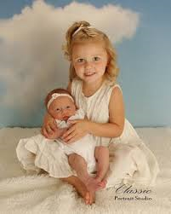
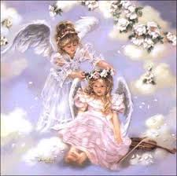
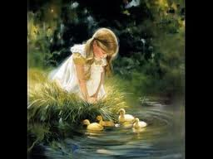

From the Desk
Of
Stan Almendro

By NO means an Expert on the Subject of children and IF I have to boast it would be about our OWN four children and those we fostered.
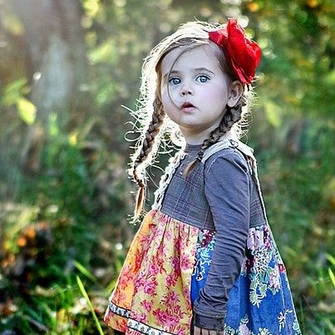

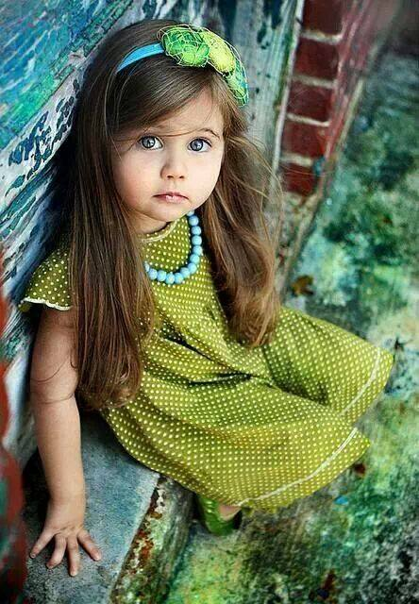

The Innocent eyes of a CHILD must drive us WILD with Love and Caring!!
We trust that writers who contribute to this column and the articles we download from the Net (If an objection is received from the writer of the articles we download we will gladly remove it from our column) will Light a Spark of JOY and Excitement in us to become part of a WORLD team of Authors, who if they have children or they are involved with children, WRITING BOOKS (REARING CHILDREN) that will be and are read by the world!!

A Child Should never have to PONDER on their OWN safety, Protection and CARE because these valued ELEMENTS should be the NATURAL overflow of the HEARTS of PARENTS who are sufficiently in Love to have AN offspring who can and MUST be VICTIMS of their Loving, Kind and Caring Hearts

From the Desk
Of

June Potter

JESUS LOVES THE LITTLE CHILDREN.

Who knows the way into a child’s fragile and tender heart? Surely the entrance is that of trust and a knowledge of self so very long ago? Innocence shines forth from eyes that see all as pure and for the taking yet a hesitance comes forth from the spirit when unsure if this can surely be. Grace abides with in the reach of every small child for does not our Lord Jesus call the little ones to His side where they may experience unconditional love and an inner freedom thus able to be the very best and complete version of themselves. Faith is every young child’s trade mark for what is told to them is believed due to the trust abiding deep within their heart of truth. Born to know that their life matters is a gift given by every parent yet when the ashes of deceit and un ending strife fill the home with trauma and tangible fear, all little ones breathe in the unholy spirit of feeling not wanted and loved. Growth is the way forward but growth needs to be rooted and grounded in a home filled with an atmosphere of hope, love and the ability to be one’s self not a version of a parent needing to live their life through the now growing child. When residing within the comfortable and safe womb of the mother to be, every tiny baby knows its worth, whether wanted and cherished or that of being a burden due to an unexpected pregnancy.
The birth of a baby is a miracle which needs to be celebrated as a bountiful gift; a treasure given due to love divine. Nothing is impossible with Him who sees and knows all things and although there is no easy way in which to train up a child, He is always by your side if you will but call out. From the beginning of time He knew about this little one, every detail was already written within His heart of tender mercy and amazing grace thus He is but a prayer away when you know not the way forward. Take hold of this moment in time for in the twinkling of an eye all changes and this small bundle of immense joy has become a young adult with their own dreams and goals. Never will they forget what was taught to them even when they perhaps stray from His path. To delight yourself in your child is to become the anchor they are going to need at given times.
Within our own adult hearts is the mirror of our children, who we were once upon a time…small and innocent children just waiting to discover the big wide world. Be safe and secure little ones, knowing Jesus Christ is just as much your Lord as He is ours. His angels watch over you as you move forward in this very busy world.
“Jesus loves the little children; all the children in this world. Yellow, black and red and white; all are precious in His sight. Jesus loves the little children in this world

From the Desk
Of
Stan Almendro

The Patter of Small Feet

Her house is full of laughter and the patter of small feet
The gift that God has given her is so precious and so sweet
They trust in everything she says and does for them each day
You often hear them giggle when she hides the sweets away

They know that when she hides them it's a game she loves to play
Because her heart, her life, emotions all will quickly make her say
Come see what granny has for you and choose just what you will
Don't just take one, dig deep your hands and make your pocket full

She gives all of what she has and would let them have her soul
No power in her loving heart to refuse or things withhold
No price to pay for grannies love it is a part of her dear heart
And when she's given everything she’s hardly made a start

It's just enough for her to hear oh Granny I love you so
But even if they cannot speak it something she just knows
The laughter in this little house and the patter of small feet
Is Gods’ reward and precious gift for children are so sweet

