OUR KIDZ WORLD
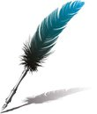
December 2019
Making this WORLD a BETTER Place
Each month this column will have Items of News, Articles of Hope!!
This February edition I believe is one of the more (Or Most) important and URGE every Mother and Father to read it, Discover the TRUTH of it. More importantly DISCOVER the truth about yourself MEASURED against the HEART of the Greatest Father EVER (God)
Articles to help parents understand and cope with the “Everyday Living in the World of a Child”
Material posted in this “Column” will be at the discretion of the Editor with the SOLE purpose of bringing about a greater awareness of our children and for the “Good of the Children”
The opinions expressed here, although allowed by the editor, are not necessarily the opinion of the Editor and the Club.
The AIM is to PUBLISH material “For the Good of the Children and this can include:
- Videos
- Photographs
- Music & Songs
- Articles of Hope and Good News
- Articles HIGHLIGHTING the plight of our Children
- Articles from Professionals in the Care of Children
- Articles from Children (Parents to give written consent before Publishing)
- NEWS of WHATSOEVER nature that will give a GREATER awareness of the “Precious Gifts that God has Given”
The material can be sent to stan@whisperpoetry.com and must reach us before the 25th of each month for Publication in the Column for the following month.
There is NO restriction other than that:
“ALL MATERIAL MUST BE SUITABLE FOR FAMILY VIEWING”

CLICK on this “In My Daughters Eyes” to watch the Video of the Month
https://www.youtube.com/watch?v=YYxbdP-bHIg
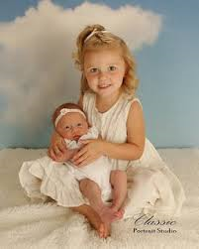
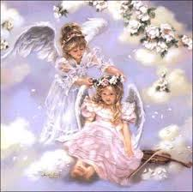
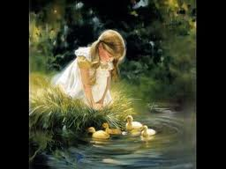

From the Desk
Of
Stan Almendro

By NO means an Expert on the Subject of children and IF I have to boast it would be about our OWN four children and those we fostered.
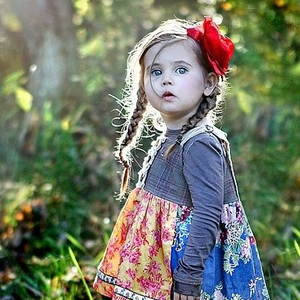

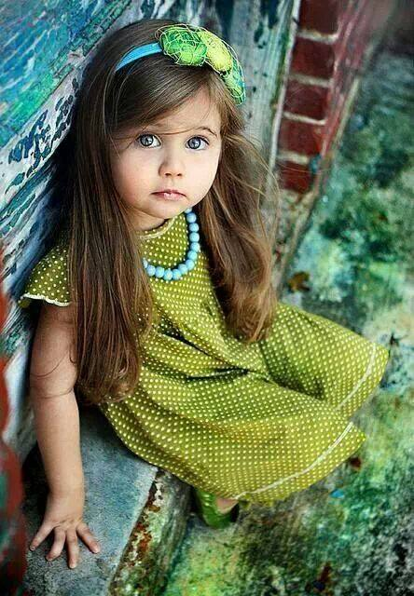

The Innocent eyes of a CHILD must drive us WILD with Love and Caring!!
We trust that writers who contribute to this column and the articles we download from the Net (If an objection is received from the writer of the articles we download we will gladly remove it from our column) will Light a Spark of JOY and Excitement in us to become part of a WORLD team of Authors, who if they have children or they are involved with children, WRITING BOOKS (REARING CHILDREN) that will be and are read by the world!!

A Child Should never have to PONDER on their OWN safety, Protection and CARE because these valued ELEMENTS should be the NATURAL overflow of the HEARTS of PARENTS who are sufficiently in Love to have AN offspring who can and MUST be VICTIMS of their Loving, Kind and Caring Hearts

From the Desk
Of

June Potter

HEAR THE VOICE OF A CHILD

Tell me little child…why do you cry
Can you no longer contain the need to feel secure
And what may I ask is the mark of security to one so small
More and more of your own way; screaming; kicking and shouting
Temper tantrums making all feel they want to run and hide
Is this the need you are expressing…or just maybe deep within your tiny heart you long to feel safe in the comfort of those who ensure your boundaries
What are the words you are sharing from a voice; a mind; that is still too immature to fully understand?

Hold me close to your heart; protect me with boundaries that reveal to me you are an adult…my mother…my father…the one on whom I can depend
To say no when needed or else I may fall; burn myself; walk into unknown traps impossible for me to understand as yet
To teach me inner discipline…
Inner strength

The difference between good and evil in days to come
Can you not see; adult parents; that I am but a fragile growing being trying to find and establish my footprints in this harsh world you take for granted
I need and long for the safe feeling you give my delicate mind and tender spirit when your words are real; true and unchanging
Please do not sway from pillar to post…one day this and another that
Fighting you and crying for my own way will become the norm for me if I am out of my comfort zone of loving discipline
Hear what I am trying to share when I pout and am moody
Love me always and in the same way day after day
And so you will teach me that love is unconditional and not dependent on what I say or do the correct way
You are grown up and may have forgotten the insecurities you had when you were my young age
Help me…
Teach me to face this huge world and I in turn will bring back the delights of childhood with all its newness and innocence
I am but a child.

From the Desk
Of
Stan Almendro

The Patter of Small Feet

Her house is full of laughter and the patter of small feet
The gift that God has given her is so precious and so sweet
They trust in everything she says and does for them each day
You often hear them giggle when she hides the sweets away

They know that when she hides them it's a game she loves to play
Because her heart, her life, emotions all will quickly make her say
Come see what granny has for you and choose just what you will
Don't just take one, dig deep your hands and make your pocket full

She gives all of what she has and would let them have her soul
No power in her loving heart to refuse or things withhold
No price to pay for grannies love it is a part of her dear heart
And when she's given everything she’s hardly made a start

It's just enough for her to hear oh Granny I love you so
But even if they cannot speak it something she just knows
The laughter in this little house and the patter of small feet
Is Gods’ reward and precious gift for children are so sweet

